Habitat calculation using statistical models

Basic concept

Generalities
All hydraulic habitat models contribute to the definition of “e-flows” (environmental flows), seen as compromises between water uses and the ecological status of rivers. The use of habitat models fits into a global approach that takes into account the hydrological, environmental, biological and socio-economic context. The implementation and interpretation of habitat models is not immediate and requires expertise. The place of habitat models in the global approach is described for example in the following documents, whose reading is recommended for proper interpretation:
'Lamouroux N., Hauer C., Stewardson M.J., Poff N.L. (2017) Physical habitat modeling and ecohydrological tools. In Horne A., Webb A., Stewardson M.J., Richter B., Acreman M. (Eds). Water for the Environment. Elsevier, Amsterdam. p. 265-285. https://dx.doi.org/10.1016/B978-0-12-803907-6.00013-9'
'Lamouroux N., Augeard B., Baran P., Capra H., Le Coarer Y., Girard V., Gouraud V., Navarro L., Prost O., Sagnes P., Sauquet E., Tissot L. (2018) Débits écologiques : la place des modèles d'habitat dans une démarche intégrée. Hydroécologie Appliquée, 20, 1–26. https://doi.org/10.1051/hydro/2016004'
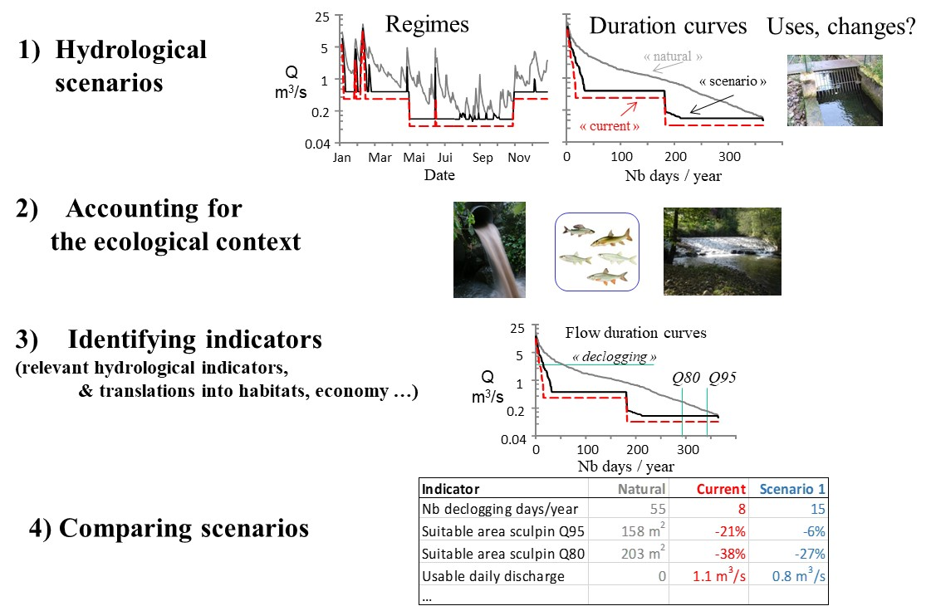Example of a consensual scenario-based approach, used in France for setting e-flows (from Lamouroux et al., 2018)
The general principle of hydraulic habitat models is to couple a hydraulic model that describes the hydraulic characteristics of microhabitats (flow velocity, water depth, etc.), with preference models for species and/or life stages and/or groups of species for these characteristics. Most often used at the scale of stream reaches, these habitat models make it possible to map habitat values ​​(“Hab_Val” or “OSI”, often standardized in the form of suitability scores varying between 0 and 1) that reflect the quality of the hydraulic habitat for the taxon considered. A variation of the reach-averaged habitat value or of a “weighted usable area” WUA (m2, “SPU” in French, product of the habitat value and the surface surface area) can then summarize the impact of a variation in flow on the quality of the hydraulic habitat.
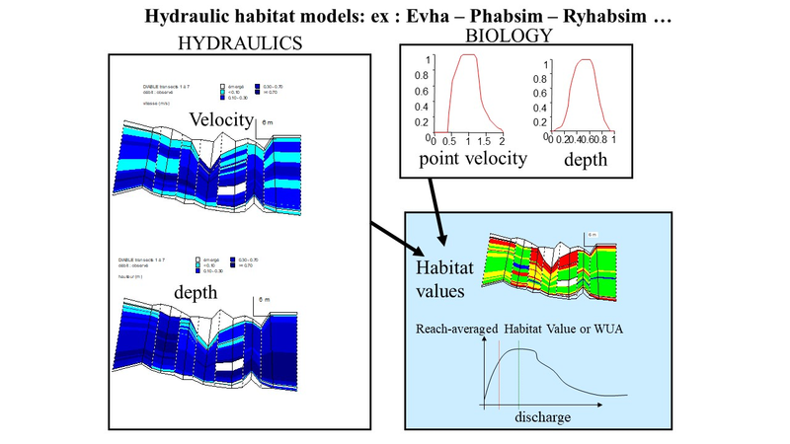The principle of numerical, traditional habitat models : linking a hydrodynamic model with biological models of microhabitat selection
Most habitat models are numerical, as they are based on a numerical hydrodynamic model (nowadays often two-dimensional) which solves the mass and energy conservation equations within the reach. Numerical models require three-dimensional bed topography data and expert hydraulic calibration.

Statistical habitat models
Statistical habitat models are simple alternatives to numerical habitat models, frequently used in France but which have spread in Europe, America, Oceania or Asia. The models described here are of two types:
- Stathab, Stathab_steep and FSTress models are based on a direct modeling of the statistical distributions of the point hydraulic variables in the river sections (histograms of point flow velocities, water heights, bed shear stress). These distributions are of similar and predictable shapes in a very wide range of streams. They essentially depend on the so-called “hydraulic geometry” of the river reaches, i.e. the average characteristics of these reaches (width and depth) at different flows.
- The Estimhab model is a direct, statistical model of the results of a digital hydraulic habitat model (Evha, used in France, twin of the North American Phabsim software). The Evha model was applied to several dozen rivers, for a fixed list of taxa. As the distributions of the hydraulic microhabitats depend on the hydraulic geometry of the reach… so do the outputs of Evha. This is the principle of Estimhab.
FSTress, Stathab and Stathab_steep software can be coupled with all available hydraulic preference models (including the many gathered in Habby), based on bed stress (FSTress) or based on water depth and flow velocity (Stathab, Stathab_steep). They are thus more flexible than Estimhab, for which the list of modeled taxa is fixed. These 3 models estimate the quality of the hydraulic habitat, and do not take into account the preferences for the substrate in their current version. This may explain generally higher habitat values ​​than with Estimhab.
Statistical models do not allow mapping of habitat values, and do not apply in highly altered morphologies (e.g. channelized, recalibrated). On the other hand, they are simpler to implement than numerical models, because their main input is the average characteristics of the river sections (discharge, width, water depth, particle size of the substrate) measured at two distinct flow rates. Thus, when habitat value mapping is not required, they greatly facilitate hydraulic habitat modeling. Their simplicity also facilitates applications in multiple sites and simulations on large-scale hydrographic networks.

Statistical models
- Estimhab is a statistical model of the numerical model Evha. It was developed in temperate streams of slope < 5%.
'Lamouroux N., Capra H. (2002) Simple predictions of instream habitat model outputs for target fish populations. Freshwater Biology 47, 1543-1556. Lamouroux N., Souchon Y. (2002) Lessons from instream habitat modelling for fish communities. Freshwater Biology 47, 1531-1542. Lamouroux N., Jowett I.G. (2005) Generalized instream habitat models. Canadian Journal of Fisheries and Aquatic Sciences, 62, 7-14.'
- Stathab is based on the statistical modeling of the frequency distribution of point velocities and water depth in stream reaches. In the current version of the model, point velocities and depth are considered statistically independent (this is the actual average situation across rivers, Schweizer et al., 2017). It was developed in the same rivers as Estimhab.
'Lamouroux N. (1998) Depth probability distributions in stream reaches. Journal of Hydraulic Engineering, 124, 224-227. https://doi.org/10.1061/(ASCE)0733-9429(1998)124:2(224) Lamouroux N., Souchon Y., Hérouin E. (1995) Predicting velocity frequency distributions in stream reaches. Water Resources Research, 31, 2367-2375. https://doi.org/10.1029/95WR01485''
- Stathab_steep is based on the statistical modeling of the frequency distribution of point velocities and water depth in stream reaches. In the current version of the model, point velocities and depth are considered statistically independent (this is the actual average situation across rivers, Schweizer et al., 2017). Close to Stathab, it was developed in tropical and alpine streams with slopes up to 25% and large roughness.
'Girard V., Lamouroux N., Mons R. (2014) Modeling point velocity and depth statistical distributions in steep tropical and alpine stream reaches. Water Resources Research, 50, 427–439. https://doi.org/10.1002/2013WR013894 '
- FSTress is based on the statistical modeling of the frequency distribution of bed shear stress in stream reaches, and is particularly useful for modelling habitats of macroinvertebrates.
'Lamouroux N., Statzner B., Fuchs U., Kohmann F., Schmedtje U. (1992) An unconventional approach to modeling spatial and temporal variability of local shear stress in stream segments. Water Resources Research, 28, 3251-3258. https://doi.org/10.1029/92WR01761 '
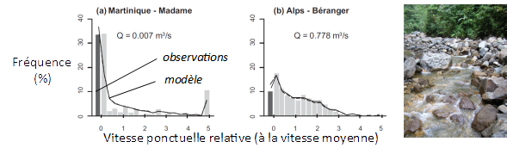Examples of statistical hydraulic models (Girard et al. 2014) predicting velocity distributions in stream reaches of different rivers. The approach is particularly relevant in very complex flows (tropics, mountains). The input variables of statistical models are simple to measure, which facilitates their use for studies at the scale of the reaches as well as at the scale of the watersheds.
Please send the input files of your studies, field data and location of station boundaries to INRAE ​​(nicolas.lamouroux@inrae.fr). This feedback drives the methods forward. We encourage project owners to request them, because files participate in quality control.

Validity ranges

Generally
The calibration domains of the different software are indicated below (physical characteristics), by software. Statistical habitat models do not apply in highly altered morphologies (e.g. channelized, recalibrated). It is generally possible to apply the software outside of their calibration domain, particularly in rivers whose width or mean flow deviates reasonably from the calibration domain, because the approach is based on the existence of very general statistical properties of rivers (shape of velocity and depth distributions). Nevertheless, we recommend discussing these points with the technical experts involved in the studies, and in any case, applications should be limited to rivers with diversified geomorphic units. Thus, avoid using the models in reaches with more than 40% of the surface area under the hydraulic influence of weirs, riprap, groynes or other developments.
The domains of validity of HABBY's biological models are now documented in the HABBY software itself, which also serves as a library of numerous biological models. Only a few elements concerning Estimhab will be described below.
WARNING. All units for statistical models are in m, m/s, m3/s.

Specificities

Estimhab
Biological validity rangeUnlike other statistical software, the list of modeled taxa is fixed. Estimhab allows habitat simulations by species/stages or by groups of species/stages (guilds).
The European species currently taken into account are: TRF = adult and juvenile Fario trout (the simulations for juvenile trout remain valid for fry); BAF = adult river barbel; CHA = adult sculpin; GOU = adult gudgeon; LOF = adult stone loach; VAI = adult minnow; SAT = Atlantic salmon (alevin and juvenile); OMB = grayling (fry, juvenile, adult).
Guilds are groups of species/stages with comparable habitat preferences. The guilds used for Estimhab are:
- Guild 'riffle': loach, sculpin, barbel <9cm
- Guild ‘midstream’: barbel >9cm, blageon >8cm (this guild is considered appropriate for nase, toxostome, dace, grayling)
- Guild ‘pool’: eel, pumpkinseed, perch, roach, chub >17cm
- Guild ‘bank’: gudgeon, blageon <8cm, chub <17cm, minnow
The 'channel' guild corresponds to midstream species; it is the guild most favoured by increases in flow (and historically the most affected by reduced flows in regulated rivers). The general slowdown in runoff linked to developments also reduces the proportion of species in the 'riffle' guild.
All the biological models that were used to build Estimhab are now documented in HABBY HABBY\biology\models\France\fish\Irstea Former Cemagref

Physical range of validity
Estimhab can be used in rivers with temperate climates with a natural or slightly modified morphology (the flow rate can be modified), with a slope < 5%.
Simulations by species (except those of SAT and OMB) are quite comparable to those of EVHA (>80% variance in explained habitat value) in a range of rivers whose hydrological and hydraulic characteristics are below:
Reach characteristics | Minimum | Maximum
Median discharge Q50 (m3/s) | 0.20 | 13.10
Width at Q50 (m) | 5.15 | 39.05
Depth at Q50 (m) | 0.18 | 1.45
Substrate D50 (m) | 0.02 | 0.64
Simulations by guilds, (plus those for SAT and OMB) were comparable to those of EVHA in a wider range of rivers :
Reach characteristics | Minimum | Maximum
Median discharge Q50 (m3/s) | 1.00 | 152.00
Width at Q50 (m) | 7.00 | 139.00
Depth at Q50 (m) | 0.25 | 2.25
Substrate D50 (m) | 0.01 | 0.33

Stathab
Stathab was calibrated in the same rivers as Estimhab.

Stathab_steep
Stathab_steep was calibrated in alpine and tropical rivers with the following characteristics:
Reach characteristics | Minimum | Maximum
Slope(%) | 1 | 24
Substrate, average Dm (m) | 0.001 | 0.40
Substrate, percentile D84 (m) | 0.276 | 2.56
Wetted width (m) | 1.24 | 19.5
Mean annual discharge (m3/s) | 0.047 | 2.27

FSTress
FSTress was calibrated in small to medium streams, with low particle size and the following characteristics:
Reach characteristics | Minimum | Maximum
Slope (%) | 0.07 | 3.4
Substrate, mean size (m) | 0.01 | 0.03
Wetted width (m) | 1 | 30
Mean annual discharge (m3/s) | 0.003 | 12

Input variables
The implementation, application limits and field measurement protocol of statistical habitat models are very similar, with some variations depending on the model. In particular, estimating the hydraulic geometry of reaches, by measuring widths and depths at two flow rates, is the main input variable common to all statistical software. Input variables of models are provided by the user as variables or input files. However, for Estimhab with HABBY or with Excel, some input variables are entered when running the model.

Reach choice
The models perform simulations at the scale of stream reaches, a study ideally comprising several reaches. The choice of reaches depends on the objective of the simulation. However, the application of the models assumes that the reach reflects the diversity of geomorphic units occurring along the river (riffles, runs, pools). On average along rivers, riffle-pool sequences follow each other every 6-7 times the bankfull width. Consequently, we recommend applying the method to reaches with a length > 15 times the bankfull width of the river. We recommended to carry out a summary mapping on a larger scale before choosing representative reaches. Choosing long reaches > 15 times the width does not pose a problem. On the other hand, choosing shorter reaches should only be done if necessary (eg: short bypassed section, description of a shorter fishing site): it will then be necessary to justify that the reach still contains a diversity of geomorphic units.

Estimating reach hydraulic geometry

Principle
The hydraulic geometry of the stream reach (depth-discharge, width-discharge relationships) is the essential input variable for statistical models. These relationships follow “power” laws, which means that knowing the average depth and width of the reach at two very different flow rates is sufficient for the application of the models. Most of the field measurements therefore consist in estimating, at 2 different flows (Q1 and Q2), the average water depth (H1 and H2) and the average wetted widths (W1 and W2) of the reach. These field measurements make it possible to estimate the hydraulic geometry of the reach. They are used to fill in an input file (see example file “*qhw” supplied with HABBY or the R versions) which contains the 6 values.

Choosing 2 discharge rates Q1 et Q2 for field mesurements
If we could “choose” …. The average width and depth at any flow rate are extrapolated from the measurements made at Q1 and Q2, after adjustment of power laws linking the width and depth to discharge (so-called “hydraulic geometry” laws). The extrapolations must be correct both in the simulation range and up to the median natural flow Q50 of the river. Simulations of uncertainties on the choice of measurement discharges suggest using discharges that are as contrasted as possible, with the following rules:
- Q2 > 2*Q1
- the simulation will be between Q1 / 10 et 5 * Q2
- the natural median flow Q50 is also between Q1 / 10 and 5 * Q2
- the two discharge Q1 and Q2 remain lower than bankfull flow.
It is at low flow rates that hydraulic conditions change quickly and measurements are easy, so the ideal is to choose Q1 as low as possible and Q2 closer to Q50. The time spent between the two measurement campaigns is not problematic … as long as there is no morphogenic flood.

Measuring Q1 et Q2
To estimate Q1 and Q2, if there is a gauging station in the immediate vicinity and negligible contributions between the reach and the gauge, we can refer to it. Otherwise, Q1 and Q2 must be measured in a suitable section (as rectangular as possible, with moderate-high velocities, not necessarily in the reach). Results of models are very sensitive to the estimation of Q1 and Q2, which must therefore be accurate (error < 10%).

Other hydrologic estimations
The modelling discharge range must be entered for all models (see example file “*deb” which contains two flow rate values ​​indicating this range). It should be consistent with Q1 and Q2 values as mentioned above.
Only Estimhab requires other hydrological characteristics of the section as an input variable (the median natural Q50 flow). Nevertheless, an e-flow study without knowledge of the reach hydrology makes no sense (e.g. mean discharge, high and low flows characteristics). The flow history is necessary for the interpretation of simulations, considering the life cycle of aquatic species. As for Q50, the estimation of these hydrological characteristics is a crucial point of the impact study. It is essential to describe clearly the methods used for hydrological estimations, their validation and their uncertainty.

Estimating substrate characteristics
Not all statistical software requires this, but we recommend estimating the particle size distribution regardless of the software used. In practice, we recommend measuring, at one of the two measurement rates, the size of the elements of the substrate. The field measurement protocol proposed below makes this possible.

Specificities

Estimhab
- Q50: In addition to the field measurements, the estimate of the median daily flow of the river (Q50) under natural conditions (e.g. if there was no water use) is also part of the model's input variables. Estimhab is less sensitive to the estimation of Q50 than those of the measuring discharges Q1 and Q2, but it must nevertheless remain accurate (error < 20%). We can use a nearby gauging station. Otherwise, it is necessary to extrapolate from another station, carry out repeated field measurements, or use relevant hydrological models. The extrapolation of flows from a neighbouring station is often delicate and can generate significant errors, which is why we strongly recommend accompanying it with adequate additional measurements (we do not describe the methods that can be used here). It is essential to describe clearly the methods used for hydrological estimations, their validation and their uncertainty.
- Substrate size (from field measurements): Estimhab uses the average size of the particles measured in the reach.

Stathab
Substrate (from field measurements) : Substrate sizes are entered into stahab as a grain size distribution file (see example file “*gra”) containing the frequencies (sum = 1) of 12 classes of substrate (detritus, clay, fine sand, coarse sand, < 1, <2, <3, <6, <12, <25, <100, >100, in cm)
Depth Distribution at one measuring discharge (from field measurements) : It is a less intuitive file (see example file “*dis”) that Stathab needs. It contains a depth frequency distribution at one of the measurement discharge. Its 22 lines corresponding to the sampling rate Q (Q1 or Q2), to the average depth at Q (H1 or H2) and to the frequencies (sum = 1) of 20 regular depth classes ranging between 0 and 5H (in other words, the width of each depth class is H/4).
Stathab() : also requires definitions of depth and velocity class bounds (see “bornh” and “bornv” example files) used for calculations of hydraulic variable distributions.

Stathab_steep
Slopes : compared to the implementation of Estimhab, additional field measurements are necessary or optional for Stathab_steep (see example file “*ii”). The input data consists of 3 values ​​influencing the hydraulic distributions, of which only the first is obligatory:
- the average slope of the reach (expressed in %),
- the cumulative height of waterfalls (cumulative height of falls whose height is > 20 cm) along the reach. This is estimated in the field by reach along the thalweg.
- the length of the station (m)
Particle size measurements are not necessary for the implementation of Stathab_steep. However, they are useful for other statistical hydraulic models, and more generally essential for describing the habitats of species. We therefore recommend carrying them out.

FSTress
Particle size measurements are not necessary for the implementation of Stathab_steep. However, they are useful for other statistical hydraulic models, and more generally essential for describing the habitats of species. We therefore recommend carrying them out.

Proposed field protocol

General principle
At each of the two measurement discharges Q1 and Q2 (see above concerning the choice and measurement of these flow rates), the objective is to measure approximately 100 local depths and >15 wetted widths distributed regularly in the reach, in order to estimate the average of these variables. The particle size distribution must also be estimated at one of the two flow rates.
To this end, we propose to distribute > 15 transects perpendicular to the flow along the section, to measure the wetted width of each of these transects, then to measure the water level and the grain size at regular intervals along these transects. During these operations, the location of the points does not need to be precise, since the aim is to estimate the average value of the measurements. However, importantly, measurement points must not be selected by the operator, to avoid bias.

Equipment needed
the only equipment needed is a graduated rod to measure water depth, a decameter (or a distance-meter in large rivers) to measure the wetted width. A boat is generally necessary in deep and/or fast-flowing rivers.
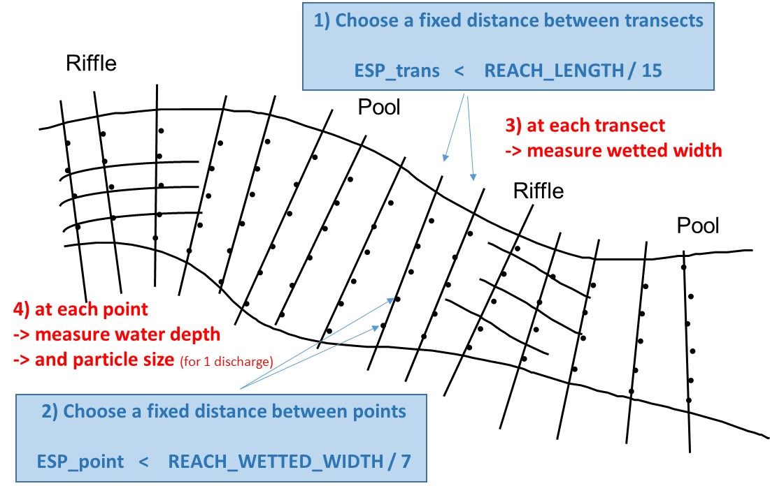

Defining a constant spacing between the transects ESP_TRANS
An 'objective' way of regularly distributing the measurement transects is to estimate approximately the length of the reach. Then, define a constant spacing between transects (ESP_TRANS < LONG / 15), to obtain more than 15 transects. Transects will be sampled with this constant spacing, from one end of the reach to the other, until you get out of the reach. The number of selected NBT transects will benefit from being increased in heterogeneous streams where the width is very variable.

Defining a constant spacing between measurement points along transects ESP_POINT
Along each transect are placed measurement points of the water level, at regular intervals (ESP_POINT), this spacing being the same for all the transects. Thus, there will be more measurement points on wide transects than on narrow transects. We recommend first to roughly estimate, before any measurement, the average wetted width of the entire section. The spacing between two measurement points along the transects will then be fixed for the entire stream so that ESP_POINT < WIDTH/7. Points are regularly distributed along the wetted width (the emerged parts are “jumped”). This will give at least 15*7 = 105 water level measurement points over the entire reach.

Measurement of the wetted width of each transect
On each of the transects, the wetted width is measured perpendicular to the main flow, a concept that is sometimes a bit vague…It is indeed the wetted width, i.e. the width actually occupied by water.
- If a 2m wide block is emerging in the middle of the river, the wetted width is equal to the total width minus 2m. Thus, the wetted width is estimated by subtracting the “emerged” width from the total width of the transect.
- If the river has several arms, the wetted widths of these arms must be added. Measurements along the transect will be along the wetted width of all arms.

Measurements of water depths along each transect
A graduated rod is sufficient to perform water height measurements. Walking precisely along the transect perpendicular to the flow is not always easy in fast flows: it is OK to drift downstream during the height measurements (walking obliquely by moving away slightly from the transect). What has to be avoided is to 'choose' the measurement points: the graduated rod is plunged blindly every ESP_POINT along the wetted width, if it falls at the top of a block, the depth over the block will be measured. We will therefore not try to target the interstices in the substrate.
The first depth measurement point along the first transect is chosen “randomly” between the edge and ESP_POINT from the bank. We stop the measurements when we arrive on the other side. If 20 cm are missing to go to the next measurement point … you can report the 20 cm to identify the first measurement point on the next transect. It is better to estimate a depth value that is difficult to access (and report it) than to omit a measurement point.

Substrate size measurements
On a 100 m long and 15 m wide reach, a transect will be chosen every 7 m (approximately 100/15), the wetted width of which will be measured (decameter or rod); Along each transect, a measurement of depth (graduated rod) and grain size (visual estimation) will be made every 2 m (about 15/7). Along the first transect, we will start the first depth measurement, randomly between 0 and 2 m from the bank. The following points are made every 2 m, until we are out of the water. The distance missing for the last depth point is transferred to the next transect, this avoids choosing the first point on the next transect.

Example
On a 100 m long and 15 m wide reach, a transect will be chosen every 7 m (approximately 100/15), the wetted width of which will be measured (decameter or rod); Along each transect, a measurement of depth (graduated rod) and grain size (visual estimation) will be made every 2 m (about 15/7). Along the first transect, we will start the first depth measurement, randomly between 0 and 2 m from the bank. The following points are made every 2 m, until we are out of the water. The distance missing for the last depth point is transferred to the next transect, this avoids choosing the first point on the next transect.

Details
Note that there is no velocity measurement, nor need to use fixed cables. This protocol is insensitive to an error of 5% on the measurements of heights and widths. The operation as a whole should last, for each measurement flow, a maximum of 2 hours for 2 people in a wadable river (a little more by boat). For each flow, the measurements are noted in a file, for example in the 'field data' sheet of Estimhab.
transect | width (m) | depth (m) | particle size (m)
1 | 18 | 0.05 | 0.15
 |  | 0.15 | 0.07
 |  | 0.22 | 0.05
 |  | 0.81 | 0.12
 |  | 1.00 | 0.00
 |  | 0.07 | 0.08
2 | 15 | 0.10 | 0.20
 |  | 0.50 | 0.12
 |  | etc… | etc…
In steep rivers, during field measurements, the constancy of the flow in space and time must be rigorously verified. It is also recommended to increase the number of transects when the width is spatially variable, and to increase the number of measurement points in the event of high transverse variability (reduce the point spacing). This is common in steep and/or tropical rivers. In steep rivers, using stathab_steep requires also to measure:
- the average slope of the reach (expressed in %),
and optionally:
- the cumulative height of waterfalls (cumulative height of falls whose height is > 20 cm) along the reach. This is estimated in the field by walking along the reach thalweg.
- the length of the reach (m)

A posteriori "quality control"
A few elements allow specialists to identify potential technical problems:
- the heights and widths measured are generally greater than the highest flow rate. If this is not the case, it is necessary to understand why or to question the measures.
- the hydraulic geometry exponents (exponents linking the depth and the width to discharge) generally have values ​​of the order of 0.15 (0 to 0.3) for width and of the order of 0.4 for depth
- the height and width values ​​estimated at Q50 must be realistic. The Froude Number at Q50 is generally between 0 and 0.5.
- The photos of the sections at each measurement flow make it possible to identify other problems. Providing field data is ​​necessary to allow verifications and improve the methods.

Knowing more : references

Other statistical models
Booker D.J., Acreman M.C. (2007) Generalisation of physical habitat-discharge relationships. Hydrology and Earth System Sciences 11, 141-157.
Kim H.J., Kim J.H., Ji U., Jung S.H. (2020) Effect of Probability Distribution-Based Physical Habitat Suitability Index on Environmental-Flow Estimation. KSCE Journal of Civil Engineering, 24: 2393-2402.
Rosenfeld J.S., Campbell K., Leung E.S., Bernhardt J., Post J. (2011) Habitat effects on depth and velocity frequency distributions: Implications for modeling hydraulic variation and fish habitat suitability in streams. Geomorphology 130: 127–135.
Saraeva K., Hardy T.B. (2009) Prediction of fisheries physical habitat values based on hydrualic geometry and frequency distributions of depth and velocity. International Journal of River Basin Management 7: 31-41.
Schweizer S., Borsuk M.E., Jowett I.G., Reichert P. (2007) Predicting joint frequency distributions of depth and velocity for instream habitat assessment. River Research and Applications 23: 287-302.
Wilding T.K., Bledsoe B., Poff N.L., Sanderson J. (2014) Predicting habitat response to flow using generalized habitat models for trout in Rocky Mountain streams. River Research and Applications, 7, 805-824.

On the generality/transferability of biological models of microhabitat selection
Becquet J., Lamouroux N., Forcellini F., Cauvy-Fraunié S. (submitted). Modelling macroinvertebrate hydraulic preferences in alpine streams.
'Forcellini M., Plichard L., Dolédec S., Mérigoux S., Olivier J.-M., Cauvy-Fraunié S. and Lamouroux N. (2022). Microhabitat selection by macroinvertebrates: generality among rivers and functional interpretation. Journal of Ecohydraulics. https://doi.org/10.1080/24705357.2020.1858724'
'Plichard L., Forcellini M., Le Coarer Y., Capra H., Carrel G., Ecochard R., Lamouroux N. (2020) Predictive models of fish microhabitat selection in multiple sites accounting for abundance overdispersion. River Research and Applications, 36, 1056–1075. https://doi.org/10.1002/rra.3631'

Model applications
Capra H., Sabaton C., Gouraud V., Souchon Y. & Lim P. 2003. A population dynamics model and habitat simulation as a tool to predict brown trout demography in natural and bypassed stream reaches. River Research and Applications, 19: 551-568.
Damiani M., Lamouroux N., Pella H., Roux P., Loiseau E., Rosenbaum R. (2019) Spatialized freshwater ecosystem Life Cycle Impact Assessment of water consumption based on instream habitat change modeling. Water Research, 163, 114884.
Lamouroux N., Gore J.A., Lepori F. & Statzner B. (2015) The ecological restoration of large rivers needs science-based, predictive tools meeting public expectations: an overview of the Rhône project. Freshwater Biology, 60, 1069-1084.
Lamouroux N. & Olivier J.-M. (2015) Testing predictions of changes in fish abundance and community structure after flow restoration in four reaches of a large river (French Rhône). Freshwater Biology, 60, 1118-1130.

R Documentation: stathabmod package
Authors:
- nicolas.lamouroux -at- inrae.fr
- virginie.girard –at- univ-grenoble-alpes.fr
- https://ecoflows.inrae.fr/software/
Download and install the stathabmod package https://ecoflows.inrae.fr/software/ Run the examples included in the R documentation of
- Stathab()
- Stathab_steep()
- FSTress()
- Estimhab()
Don’t forget to read this general documentation “Statistical_habitat_models_documentation”,
Main R functions
stathab() | Statistical hydraulic habitat models based on water depth and flow velocity
stathab_steep( ) | Statistical hydraulic habitat models for steep rivers (up to 25%) based on water depth and flow velocity
FSTress() | Statistical hydraulic habitat models based on bed shear stress (FST hemispheres)
Secondary functions
stathab_hyd() | The statistical hydraulic model called by stathab(). Computes depth and velocity distributions
stathab_hyd_steep () | The statistical hydraulic model called by stathab_steep(). Computes depth and velocity distributions

