Proposed field protocol

General principle
At each of the two measurement discharges Q1 and Q2 (see above concerning the choice and measurement of these flow rates), the objective is to measure approximately 100 local depths and >15 wetted widths distributed regularly in the reach, in order to estimate the average of these variables. The particle size distribution must also be estimated at one of the two flow rates.
To this end, we propose to distribute > 15 transects perpendicular to the flow along the section, to measure the wetted width of each of these transects, then to measure the water level and the grain size at regular intervals along these transects. During these operations, the location of the points does not need to be precise, since the aim is to estimate the average value of the measurements. However, importantly, measurement points must not be selected by the operator, to avoid bias.

Equipment needed
the only equipment needed is a graduated rod to measure water depth, a decameter (or a distance-meter in large rivers) to measure the wetted width. A boat is generally necessary in deep and/or fast-flowing rivers.
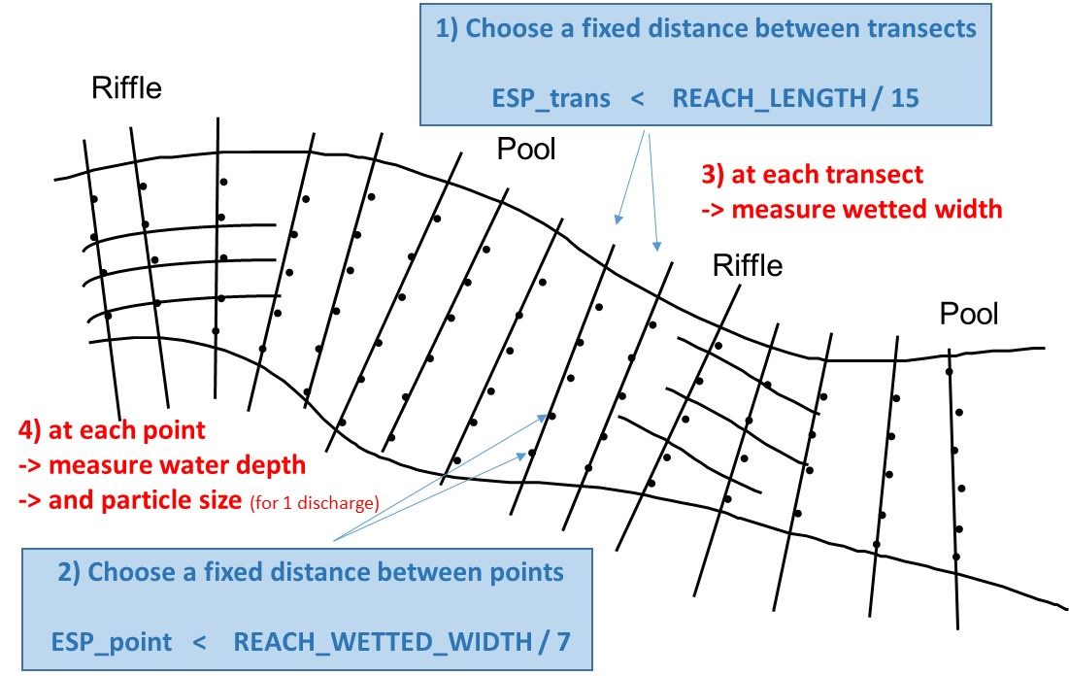

Defining a constant spacing between the transects ESP_TRANS
An 'objective' way of regularly distributing the measurement transects is to estimate approximately the length of the reach. Then, define a constant spacing between transects (ESP_TRANS < LONG / 15), to obtain more than 15 transects. Transects will be sampled with this constant spacing, from one end of the reach to the other, until you get out of the reach. The number of selected NBT transects will benefit from being increased in heterogeneous streams where the width is very variable.

Defining a constant spacing between measurement points along transects ESP_POINT
Along each transect are placed measurement points of the water level, at regular intervals (ESP_POINT), this spacing being the same for all the transects. Thus, there will be more measurement points on wide transects than on narrow transects. We recommend first to roughly estimate, before any measurement, the average wetted width of the entire section. The spacing between two measurement points along the transects will then be fixed for the entire stream so that ESP_POINT < WIDTH/7. Points are regularly distributed along the wetted width (the emerged parts are “jumped”). This will give at least 15*7 = 105 water level measurement points over the entire reach.

Measurement of the wetted width of each transect
On each of the transects, the wetted width is measured perpendicular to the main flow, a concept that is sometimes a bit vague…It is indeed the wetted width, i.e. the width actually occupied by water.
- If a 2m wide block is emerging in the middle of the river, the wetted width is equal to the total width minus 2m. Thus, the wetted width is estimated by subtracting the “emerged” width from the total width of the transect.
- If the river has several arms, the wetted widths of these arms must be added. Measurements along the transect will be along the wetted width of all arms.

Measurements of water depths along each transect
A graduated rod is sufficient to perform water height measurements. Walking precisely along the transect perpendicular to the flow is not always easy in fast flows: it is OK to drift downstream during the height measurements (walking obliquely by moving away slightly from the transect). What has to be avoided is to 'choose' the measurement points: the graduated rod is plunged blindly every ESP_POINT along the wetted width, if it falls at the top of a block, the depth over the block will be measured. We will therefore not try to target the interstices in the substrate.
The first depth measurement point along the first transect is chosen “randomly” between the edge and ESP_POINT from the bank. We stop the measurements when we arrive on the other side. If 20 cm are missing to go to the next measurement point … you can report the 20 cm to identify the first measurement point on the next transect. It is better to estimate a depth value that is difficult to access (and report it) than to omit a measurement point.

Substrate size measurements
On a 100 m long and 15 m wide reach, a transect will be chosen every 7 m (approximately 100/15), the wetted width of which will be measured (decameter or rod); Along each transect, a measurement of depth (graduated rod) and grain size (visual estimation) will be made every 2 m (about 15/7). Along the first transect, we will start the first depth measurement, randomly between 0 and 2 m from the bank. The following points are made every 2 m, until we are out of the water. The distance missing for the last depth point is transferred to the next transect, this avoids choosing the first point on the next transect.

Example
On a 100 m long and 15 m wide reach, a transect will be chosen every 7 m (approximately 100/15), the wetted width of which will be measured (decameter or rod); Along each transect, a measurement of depth (graduated rod) and grain size (visual estimation) will be made every 2 m (about 15/7). Along the first transect, we will start the first depth measurement, randomly between 0 and 2 m from the bank. The following points are made every 2 m, until we are out of the water. The distance missing for the last depth point is transferred to the next transect, this avoids choosing the first point on the next transect.

Details
Note that there is no velocity measurement, nor need to use fixed cables. This protocol is insensitive to an error of 5% on the measurements of heights and widths. The operation as a whole should last, for each measurement flow, a maximum of 2 hours for 2 people in a wadable river (a little more by boat). For each flow, the measurements are noted in a file, for example in the 'field data' sheet of Estimhab.
transect | width (m) | depth (m) | particle size (m)
1 | 18 | 0.05 | 0.15
 |  | 0.15 | 0.07
 |  | 0.22 | 0.05
 |  | 0.81 | 0.12
 |  | 1.00 | 0.00
 |  | 0.07 | 0.08
2 | 15 | 0.10 | 0.20
 |  | 0.50 | 0.12
 |  | etc… | etc…
In steep rivers, during field measurements, the constancy of the flow in space and time must be rigorously verified. It is also recommended to increase the number of transects when the width is spatially variable, and to increase the number of measurement points in the event of high transverse variability (reduce the point spacing). This is common in steep and/or tropical rivers. In steep rivers, using stathab_steep requires also to measure:
- the average slope of the reach (expressed in %),
and optionally:
- the cumulative height of waterfalls (cumulative height of falls whose height is > 20 cm) along the reach. This is estimated in the field by walking along the reach thalweg.
- the length of the reach (m)

A posteriori "quality control"
A few elements allow specialists to identify potential technical problems:
- the heights and widths measured are generally greater than the highest flow rate. If this is not the case, it is necessary to understand why or to question the measures.
- the hydraulic geometry exponents (exponents linking the depth and the width to discharge) generally have values ​​of the order of 0.15 (0 to 0.3) for width and of the order of 0.4 for depth
- the height and width values ​​estimated at Q50 must be realistic. The Froude Number at Q50 is generally between 0 and 0.5.
- The photos of the sections at each measurement flow make it possible to identify other problems. Providing field data is ​​necessary to allow verifications and improve the methods.

