Statistical models
- Estimhab is a statistical model of the numerical model Evha. It was developed in temperate streams of slope < 5%.
'Lamouroux N., Capra H. (2002) Simple predictions of instream habitat model outputs for target fish populations. Freshwater Biology 47, 1543-1556. Lamouroux N., Souchon Y. (2002) Lessons from instream habitat modelling for fish communities. Freshwater Biology 47, 1531-1542. Lamouroux N., Jowett I.G. (2005) Generalized instream habitat models. Canadian Journal of Fisheries and Aquatic Sciences, 62, 7-14.'
- Stathab is based on the statistical modeling of the frequency distribution of point velocities and water depth in stream reaches. In the current version of the model, point velocities and depth are considered statistically independent (this is the actual average situation across rivers, Schweizer et al., 2017). It was developed in the same rivers as Estimhab.
'Lamouroux N. (1998) Depth probability distributions in stream reaches. Journal of Hydraulic Engineering, 124, 224-227. https://doi.org/10.1061/(ASCE)0733-9429(1998)124:2(224) Lamouroux N., Souchon Y., Hérouin E. (1995) Predicting velocity frequency distributions in stream reaches. Water Resources Research, 31, 2367-2375. https://doi.org/10.1029/95WR01485''
- Stathab_steep is based on the statistical modeling of the frequency distribution of point velocities and water depth in stream reaches. In the current version of the model, point velocities and depth are considered statistically independent (this is the actual average situation across rivers, Schweizer et al., 2017). Close to Stathab, it was developed in tropical and alpine streams with slopes up to 25% and large roughness.
'Girard V., Lamouroux N., Mons R. (2014) Modeling point velocity and depth statistical distributions in steep tropical and alpine stream reaches. Water Resources Research, 50, 427–439. https://doi.org/10.1002/2013WR013894 '
- FSTress is based on the statistical modeling of the frequency distribution of bed shear stress in stream reaches, and is particularly useful for modelling habitats of macroinvertebrates.
'Lamouroux N., Statzner B., Fuchs U., Kohmann F., Schmedtje U. (1992) An unconventional approach to modeling spatial and temporal variability of local shear stress in stream segments. Water Resources Research, 28, 3251-3258. https://doi.org/10.1029/92WR01761 '
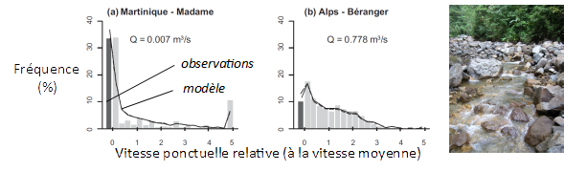Examples of statistical hydraulic models (Girard et al. 2014) predicting velocity distributions in stream reaches of different rivers. The approach is particularly relevant in very complex flows (tropics, mountains). The input variables of statistical models are simple to measure, which facilitates their use for studies at the scale of the reaches as well as at the scale of the watersheds.
Please send the input files of your studies, field data and location of station boundaries to INRAE ​​(nicolas.lamouroux@inrae.fr). This feedback drives the methods forward. We encourage project owners to request them, because files participate in quality control.

