Basic concept

Generalities
All hydraulic habitat models contribute to the definition of “e-flows” (environmental flows), seen as compromises between water uses and the ecological status of rivers. The use of habitat models fits into a global approach that takes into account the hydrological, environmental, biological and socio-economic context. The implementation and interpretation of habitat models is not immediate and requires expertise. The place of habitat models in the global approach is described for example in the following documents, whose reading is recommended for proper interpretation:
'Lamouroux N., Hauer C., Stewardson M.J., Poff N.L. (2017) Physical habitat modeling and ecohydrological tools. In Horne A., Webb A., Stewardson M.J., Richter B., Acreman M. (Eds). Water for the Environment. Elsevier, Amsterdam. p. 265-285. https://dx.doi.org/10.1016/B978-0-12-803907-6.00013-9'
'Lamouroux N., Augeard B., Baran P., Capra H., Le Coarer Y., Girard V., Gouraud V., Navarro L., Prost O., Sagnes P., Sauquet E., Tissot L. (2018) Débits écologiques : la place des modèles d'habitat dans une démarche intégrée. Hydroécologie Appliquée, 20, 1–26. https://doi.org/10.1051/hydro/2016004'
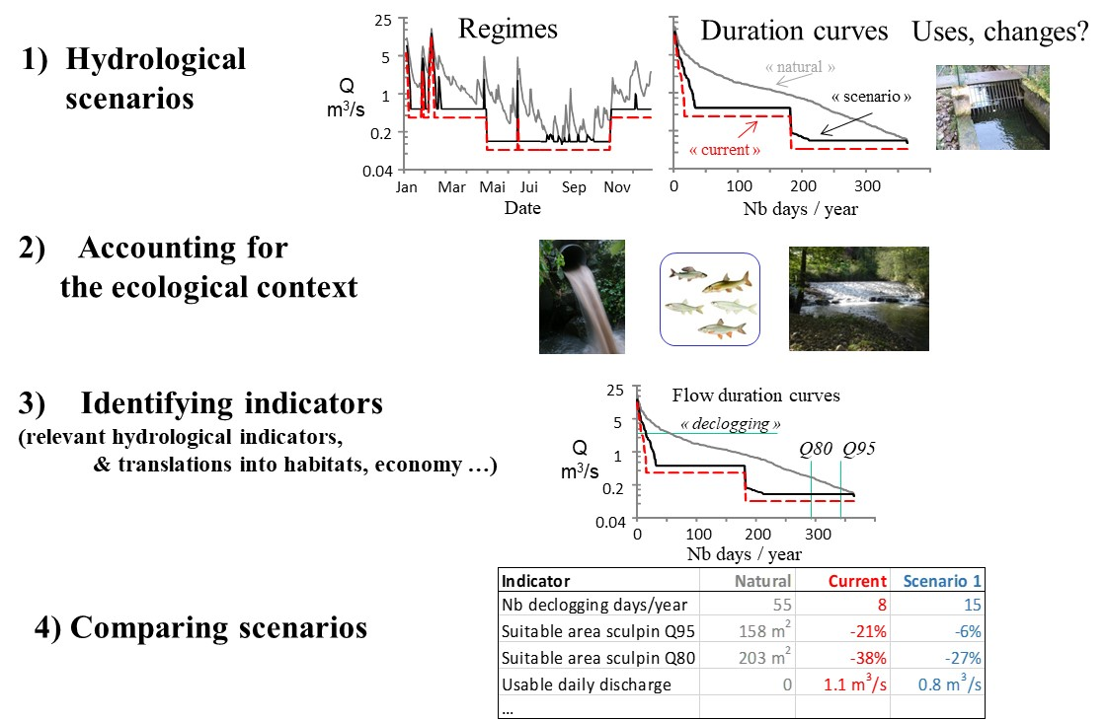Example of a consensual scenario-based approach, used in France for setting e-flows (from Lamouroux et al., 2018)
The general principle of hydraulic habitat models is to couple a hydraulic model that describes the hydraulic characteristics of microhabitats (flow velocity, water depth, etc.), with preference models for species and/or life stages and/or groups of species for these characteristics. Most often used at the scale of stream reaches, these habitat models make it possible to map habitat values ​​(“Hab_Val” or “OSI”, often standardized in the form of suitability scores varying between 0 and 1) that reflect the quality of the hydraulic habitat for the taxon considered. A variation of the reach-averaged habitat value or of a “weighted usable area” WUA (m2, “SPU” in French, product of the habitat value and the surface surface area) can then summarize the impact of a variation in flow on the quality of the hydraulic habitat.
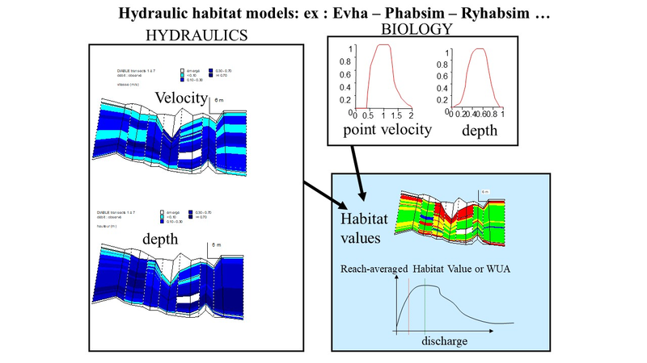The principle of numerical, traditional habitat models : linking a hydrodynamic model with biological models of microhabitat selection
Most habitat models are numerical, as they are based on a numerical hydrodynamic model (nowadays often two-dimensional) which solves the mass and energy conservation equations within the reach. Numerical models require three-dimensional bed topography data and expert hydraulic calibration.

Statistical habitat models
Statistical habitat models are simple alternatives to numerical habitat models, frequently used in France but which have spread in Europe, America, Oceania or Asia. The models described here are of two types:
- Stathab, Stathab_steep and FSTress models are based on a direct modeling of the statistical distributions of the point hydraulic variables in the river sections (histograms of point flow velocities, water heights, bed shear stress). These distributions are of similar and predictable shapes in a very wide range of streams. They essentially depend on the so-called “hydraulic geometry” of the river reaches, i.e. the average characteristics of these reaches (width and depth) at different flows.
- The Estimhab model is a direct, statistical model of the results of a digital hydraulic habitat model (Evha, used in France, twin of the North American Phabsim software). The Evha model was applied to several dozen rivers, for a fixed list of taxa. As the distributions of the hydraulic microhabitats depend on the hydraulic geometry of the reach… so do the outputs of Evha. This is the principle of Estimhab.
FSTress, Stathab and Stathab_steep software can be coupled with all available hydraulic preference models (including the many gathered in Habby), based on bed stress (FSTress) or based on water depth and flow velocity (Stathab, Stathab_steep). They are thus more flexible than Estimhab, for which the list of modeled taxa is fixed. These 3 models estimate the quality of the hydraulic habitat, and do not take into account the preferences for the substrate in their current version. This may explain generally higher habitat values ​​than with Estimhab.
Statistical models do not allow mapping of habitat values, and do not apply in highly altered morphologies (e.g. channelized, recalibrated). On the other hand, they are simpler to implement than numerical models, because their main input is the average characteristics of the river sections (discharge, width, water depth, particle size of the substrate) measured at two distinct flow rates. Thus, when habitat value mapping is not required, they greatly facilitate hydraulic habitat modeling. Their simplicity also facilitates applications in multiple sites and simulations on large-scale hydrographic networks.

